EDITING I
WHAT IS EDITING?
- Editing is a process of lining up language, images, video and sound for Presentation on the newspaper and electronic media.
- A person who edits copy (script) is called proof reader, copy editor or sub editor.
- A person who edits sound is called sound editor and a person who edits video is called video or sound editor.
- Editor comes from a Latin Phrase “e ditus” which means “to put Forward”

FOUR BASIC TYPES OF EDITING
- Print media editing (script, photo)
- Radio editing (Sound editing)
- TV (Video) editing
- Web editing

STAGES /PHASES OF EDITING
- Proofreading/ copy editing/ line editing/ substantive editing
- Proofreading
- Subediting
- Head lines
- Lay out/ make up
- Proofreading or copy editing is traditionally means reading of a proof (first script)
- Proof reading helps to correct the typographical/ grammatical and spelling errors.
- Proofreading or Copy editing is an editorial work.
- Editor does it to improve the manuscript.
- Proofreading is simplest form of editing and the cheapest.
Copy is a version of a manuscript. When a proofreader checks the copy, he marks the error by marking standard correction marks. Copy editing is a basic requirement for the English or Urdu news scripts.
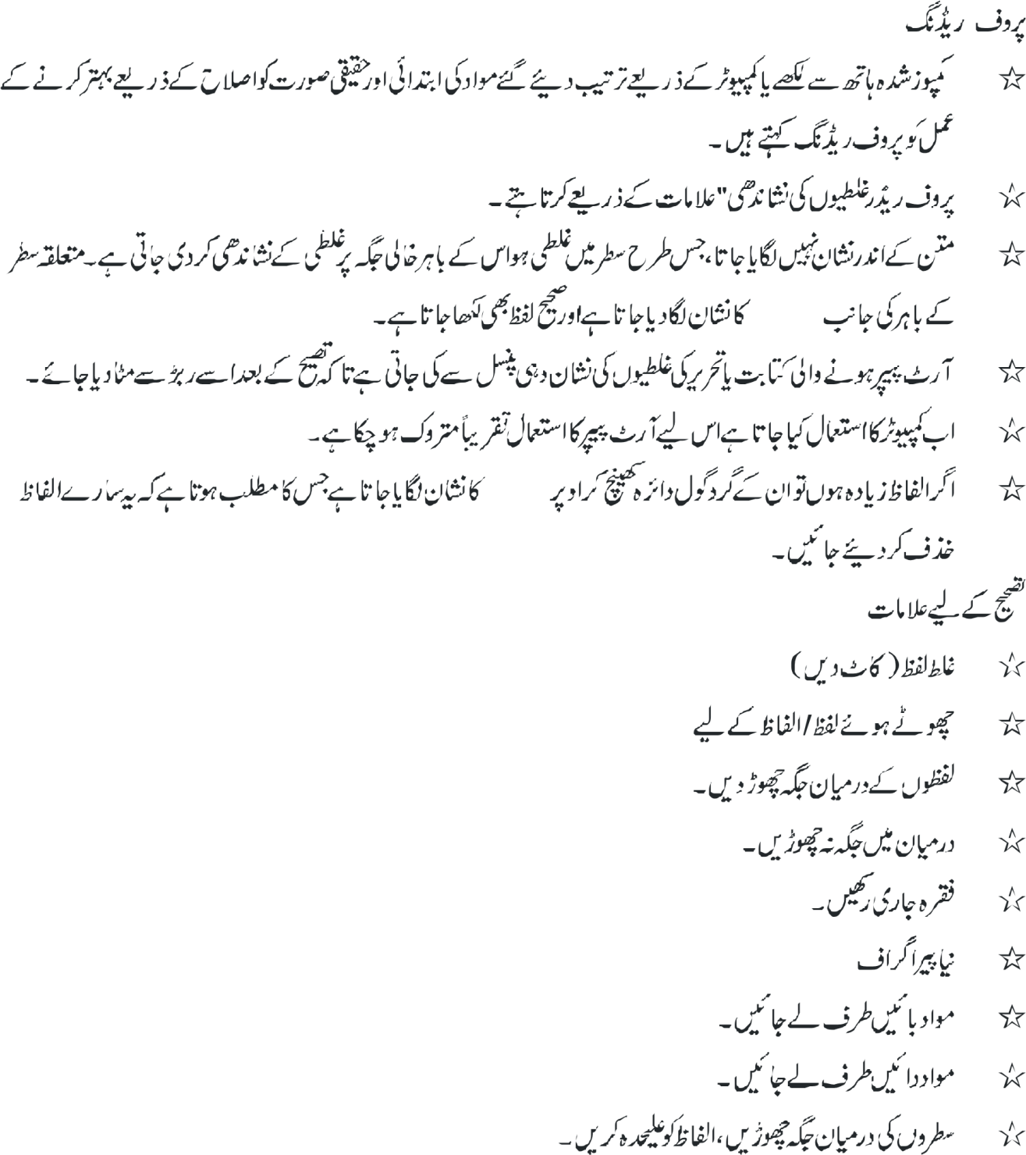

SUB EDITING

IMPORTANCE OF EDITING
- World’s famous writer T.S Eliot while writing his best poem “The wasteland” found himself struck. He asked for help of a sub editor. His friend and fellow poet Ezra Pound assisted him and a perfect piece of English literature came out.
- The original writer loves his writing but other people can examine the work critically. Every writer and reporter ends up agreeing that the copy he received back after editing is improved, more concise, more focused and more effective them that it was earlier.
- Sub editor’s role requires a significant degree of ruthlessness. Without this quality sub editor would not be able to correct or improve the copy. In fact sub editors are unknown solders almost all the award winning books. Articles, exclusive news stories are subject to sub editing.
- Sub editing is a creative activity.
- A sub editor should have the following qualities.

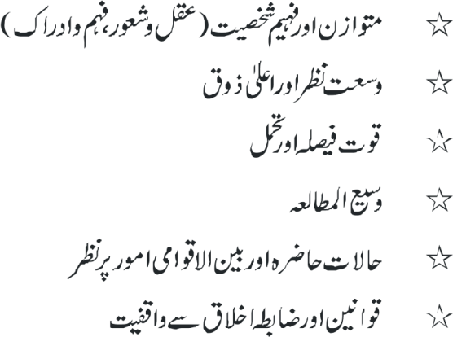

- Editing of the script may be done in a way that the intent of the copy must remain intact.
Each paragraph address only a single subject/point.
- Present facts in orderly way and with economy of words
- He must know the art of news editing
- Should have good vocabulary
- He knows how to make good sentence structure.
- Tenses should be accurate.
- Make appropriate Paragraphs
- Sub editor must have the capability to know and check the motives behind the news items
- Sub editor must replace difficult words and place alternate word in the script.
Following are some difficult words and their easy alternates.
DIFFICULT WORDS |  |  | EASY WORDS
• | Adjacent to |  |  | near
• | Prior to |  |  | before
• | In consequence of |  |  | because
• | Currently |  |  | now
• | He is man who |  |  | He
• | Fill up |  |  | fill
• | Check out |  |  | check
• | Try out |  |  | try
• | At the back of |  |  | true facts

SUB EDITING
Copy desk is a nerve centre of the news room. It is an important location in the news room. Chief Editor or the incharge of the desk sits at the center.
• The central desk is also called “The Rim”
• Desk is a place where who so ever works he learns, how to write a story, how to improve it, how to edit or how to make the headlines from the new story. In brief desk experience sharpens a future report’s skills.
RESPONSIBILITIES
• Sub editors working on desk is responsible for correcting spelling, grammar, terminology, punctuation, syntax and word usage while preserving the meaning of the original text.
• Cross checking references, art, figures, tables and other features.
• Writing, rewriting and even researching
• To check the copyrighted material
• Ensuring Checking for or imposing a consistent format.
• A sub editor has to standardized header, footers, headlines, catch line etc.
• Sub editor has to read entire text before its printing.
• Sub editors are responsible to ensure that text flows, make it sensible, fair accurate and may not provoke any legal problem.
• Sub editor’s has to summarize the copy to make it Clear, Correct, Concise, Comprehensible and Consistent
• Sub editors suppose to have vast general knowledge. This quality helps them to check the facts and the flow of language.
• Diplomacy to deal with writers/ Reporters, making suggestions about the content will annoy them.
• Editors are supposed to have a skill is writing style.
• Writing with style also involves “Organization”.
• Organizing sentences also means constructing them in a simple way.
• Organizing the right words in right place in each sentence
• Style is not a free trait. He has to follow certain rules and conventions
• Sub Editing is an art, it is not every one’s cup of tea one has to have an extra eye.
• His is the decisive authority.
• News story written by a hurried reporter is a raw diamond and an editor polishes it.
• In fact Editing is tailoring a news story to the required size and shape.
• Placed below is a list of some difficult words and their easy alternates.

